**ASSIGNMENT – 2 (DA with TABLEAU)** [**poojithakavuri02@gmail.com**](mailto:poojithakavuri02@gmail.com)

DONUT CHART:

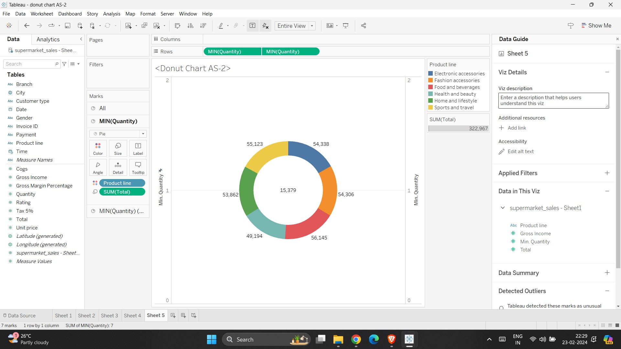

TEXT TABLE:

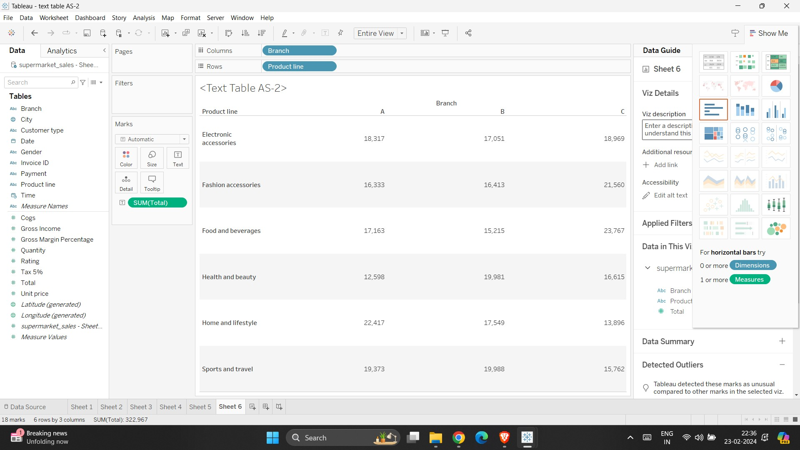

HIGHLIGHTED TABLE:

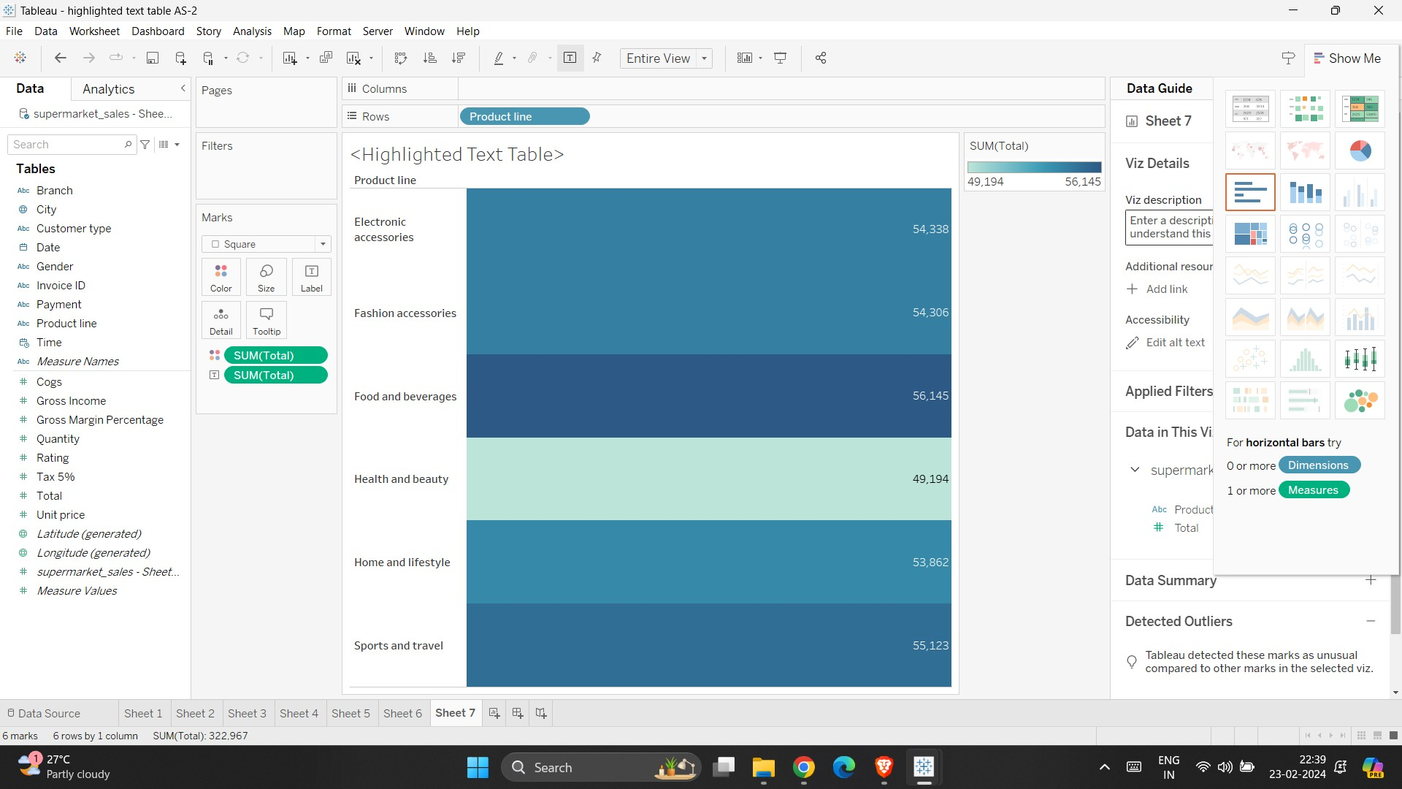

WORDCLOUD:

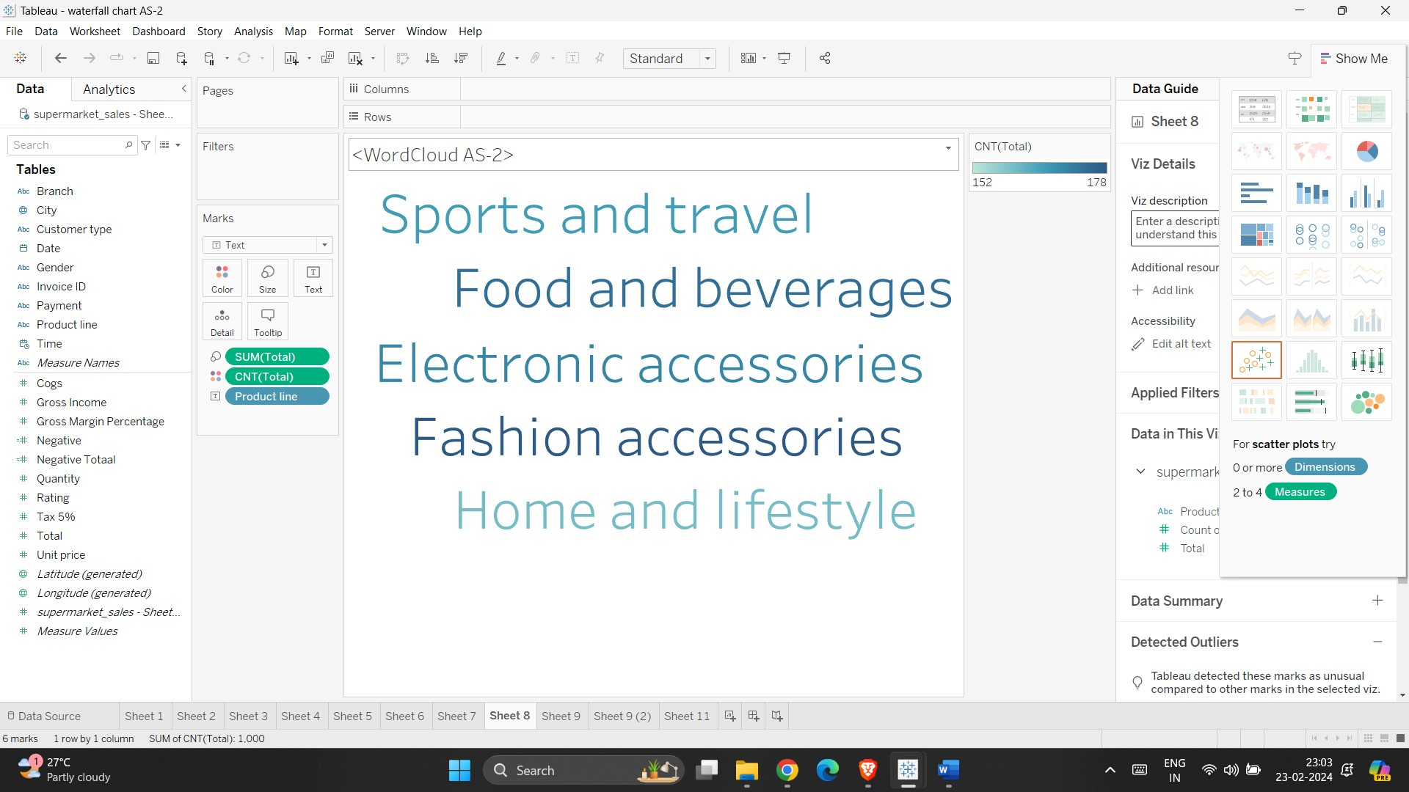

FUNNEL CHART:

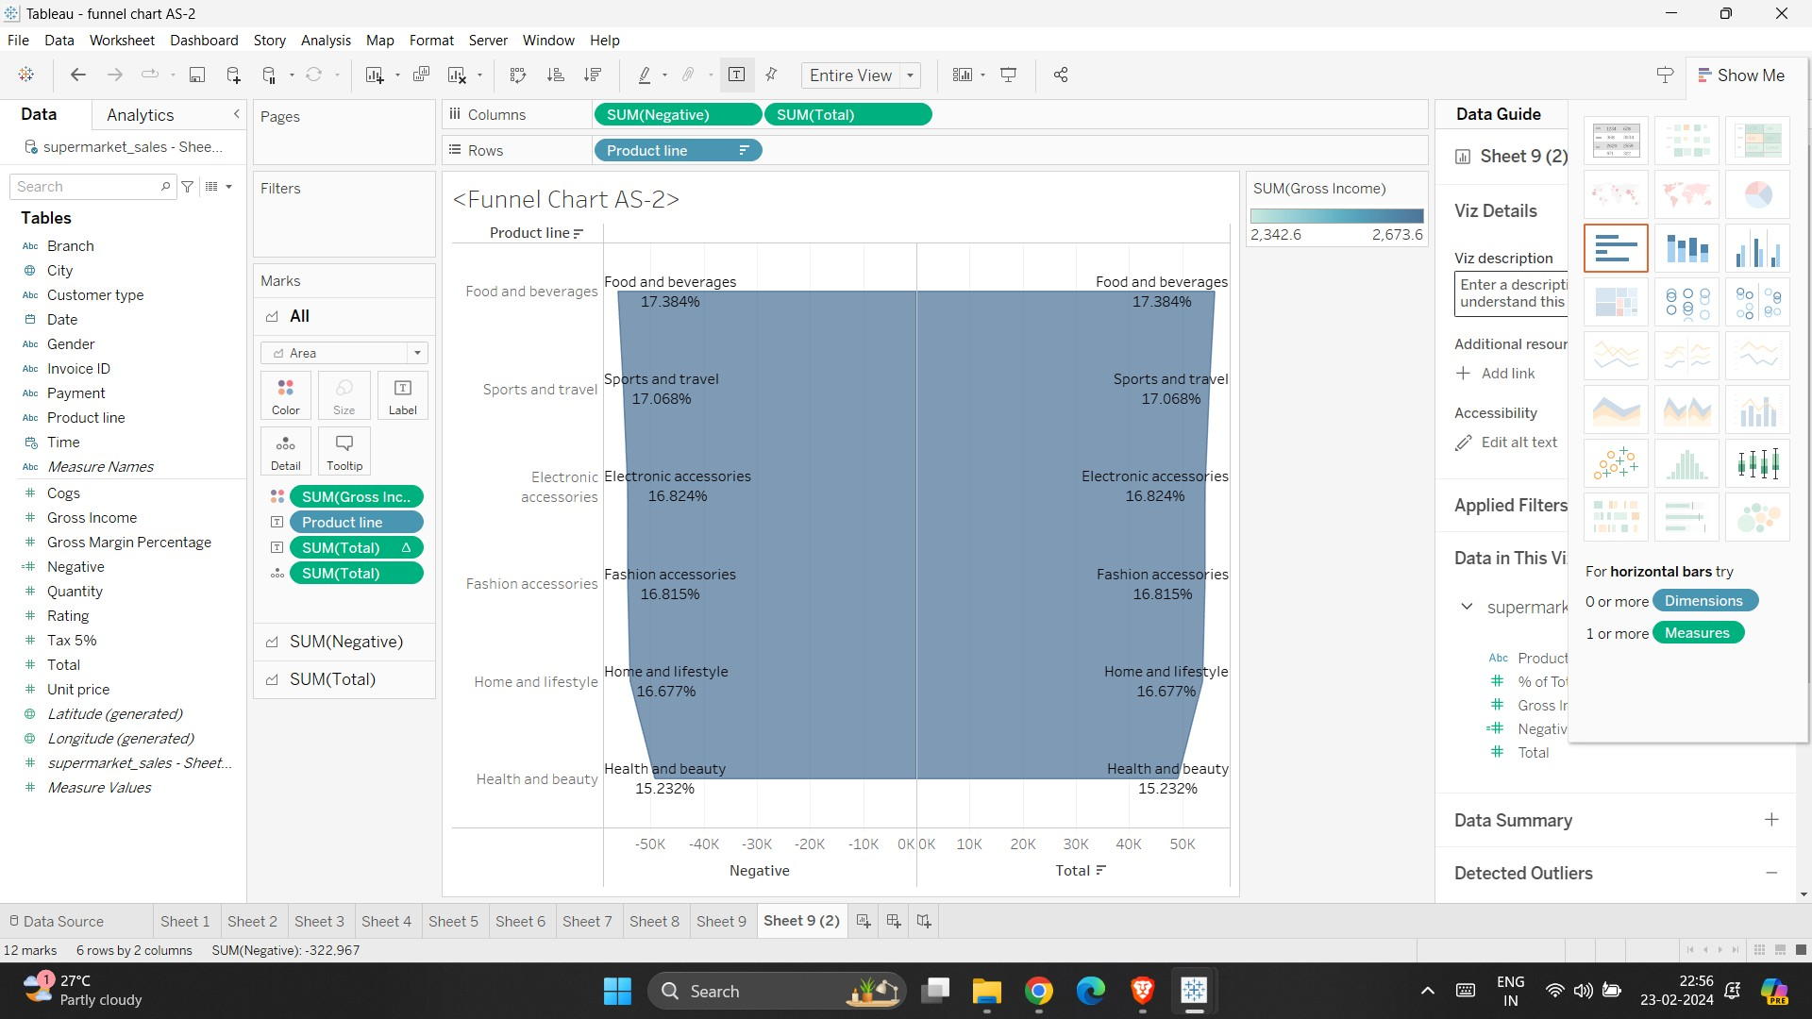

WATERFALL CHART:

